## Activity 1

**Aim:** Install using XAMPP software package for MySQL, PHP and other utilities.

# **Learning outcome**: Able to configure embedded databases with different web pages using XAMPP and MySQL.

###### Duration: 1 hour

# List of Hardware/Software requirements:

* Laptop/Computer with windows
* XAMPP software

Installation Step of Xampp Software.

Steps to install XAMPP on windows:-

Step 1: Download XAMPP First, you need to download the XAMPP software from the official website <https://www.apachefriends.org/>. On the homepage, you will see the download link for XAMPP. Click on it to download the latest version of the software.

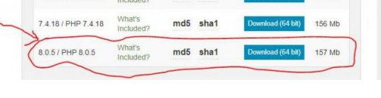

Step 2: Run the Installer After downloading, open the downloaded file and run the installer. You might see a warning message from Windows security, click on “Run anyway” to continue with the installation.

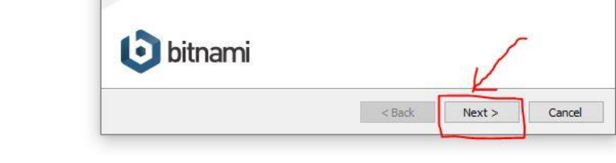

Step 3: Select Components On the XAMPP Setup Wizard screen, you will be asked to select the components you want to install. By default, all components are selected, but you can deselect those that you do not need. For instance, you might only want to install Apache, MySQL, and PHP.

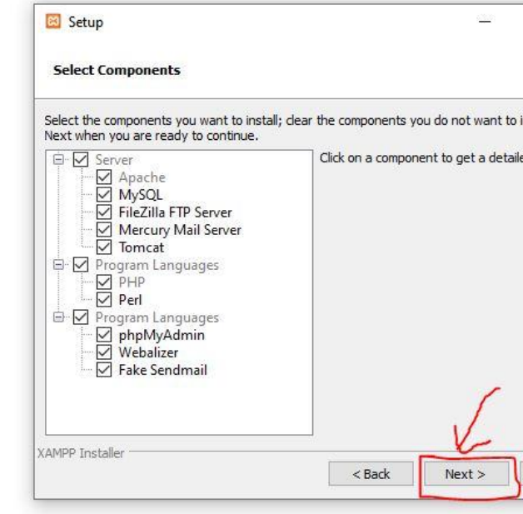

Step 4: Choose Installation Folder After selecting the components, choose the installation folder where you want XAMPP to be installed. By default, it will be installed in the C:\xampp directory, but you can change this if you wish.

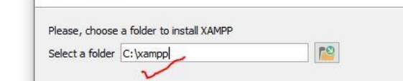

Step 5: Start Installation Once you have selected the components and the installation directory, click on the “Next” button to start the installation. The installation process may take a few minutes, so be patient.

Step 6: Launch XAMPP Control Panel Once the installation is complete, you will see the XAMPP Control Panel. You can launch it by clicking on the “XAMPP Control Panel” button.

Step 7: Start Apache and MySQL In the XAMPP Control Panel, click on the “Start” button next to Apache and MySQL to start the servers. If the servers are started successfully, you will see a green checkmark next to them.

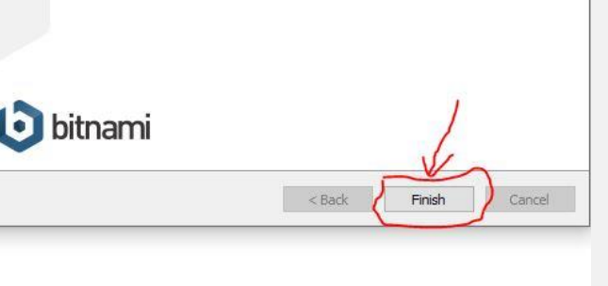

Step 8: Verify Installation To verify that XAMPP has been installed correctly, open a web browser and go to <http://localhost/>. You should see the XAMPP welcome screen.

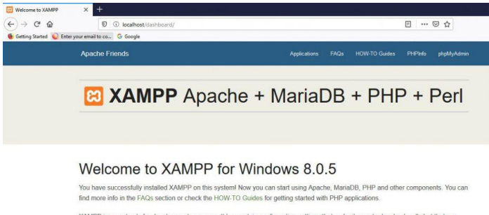

That’s it! You have successfully installed XAMPP software on your computer. Now you can start developing your web applications.

## Activity 2

**Aim:** Connect to MySQL database system and create new database.

# **Learning outcome**: Able to configure embedded databases with different web pages using XAMPP and MySQL.

###### Duration: 1 hour

# List of Hardware/Software requirements:

* Laptop/Computer with windows
* XAMPP software